
School of computer Science and engineering
Faculty of Engineering & Technology, Jain (Deemed-To-Be) University.
B. Tech CSE-GENERAL
Data Structure USING C

Title: ATM Banking System

Submitted to
Dr. Vikram N
Submitted by
Ankit TImilsena

Introduction
An Automated Teller Machine (ATM) is an electronic banking system that allows customers to perform financial transactions without visiting a bank. The ATM Banking System project is a simple console-based application developed using the C programming language. It enables users to perform basic banking operations such as checking account balance, depositing money, and withdrawing money.
This project demonstrates the use of fundamental C programming concepts including data types, variables, operators, input/output functions, conditional statements, loops, and switch-case statements. It provides a practical understanding of how these concepts are applied in real-world banking applications.

Objective
The objectives of this project are:
- To understand the fundamentals of C programming.
- To implement menu-driven programs using switch-case.
- To use loops for repeated execution of operations.
- To perform basic banking transactions such as deposit and withdrawal.
- To develop problem-solving skills through a real-world application.

Table of Contents
- Introduction 2
- Objective 2
- Table of Contents 3
- Source Code
- Sample Output
- Conclusion
- References

SOURCE CODE
#include <stdio.h>

int main()
{
int choice;
float balance = 10000.0, amount;

do
{
printf("\n=================================\n");
printf(" ATM BANKING SYSTEM\n");
printf("=================================\n");
printf("1. Check Balance\n");
printf("2. Deposit Money\n");
printf("3. Withdraw Money\n");
printf("4. Exit\n");
printf("Enter your choice: ");
scanf("%d", &choice);

switch(choice)
{
case 1:
printf("\nCurrent Balance = Rs. %.2f\n", balance);
break;

case 2:
printf("\nEnter amount to deposit: ");
scanf("%f", &amount);

if(amount > 0)
{
balance = balance + amount;
printf("Amount Deposited Successfully!\n");
printf("Updated Balance = Rs. %.2f\n", balance);
}
else
{
printf("Invalid Amount!\n");
}
break;

case 3:
printf("\nEnter amount to withdraw: ");
scanf("%f", &amount);

if(amount > 0 && amount <= balance)
{
balance = balance - amount;
printf("Amount Withdrawn Successfully!\n");
printf("Remaining Balance = Rs. %.2f\n", balance);
}
else
{
printf("Insufficient Balance or Invalid Amount!\n");
}
break;

case 4:
printf("\nThank You for Using ATM Banking System.\n");
break;

default:
printf("\nInvalid Choice! Please Try Again.\n");
}

} while(choice != 4);

return 0;

output of the program
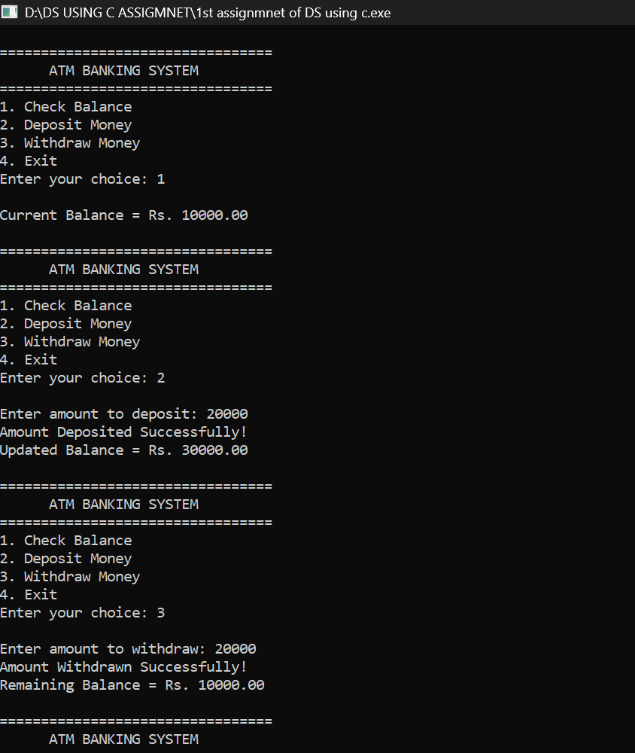
Conclusion
The ATM Banking System project successfully demonstrates the implementation of basic banking operations using the C programming language. Through this project, concepts such as variables, data types, operators, conditional statements, loops, and switch-case statements were effectively utilized. The project provides practical experience in developing menu-driven applications and helps build a strong foundation in programming.

